Practical exam AZ-104 part 2

This exam is composed by one task:

Configuring ACR and AKS.

**Remarks:**

It is important that you take **screenshots** during each process of solving the exercises, as well as **commenting** on what you are always doing, differentiating your comments from the exam statement using the **Spanish** language and a different color or a marker.

You are allowed to access information on the Internet or **your** own class notes. But any attempt to communicate with a classmate or external person, if detected, implies failing the exam with a 0 and the risk of being dropped from the master's degree.

Before starting the exam, each student will have to create in their server account, in the AZ-104 folder, a new folder with the name "Examen P2". You will place a copy of the exam document (“Examen Práctico 2 AZ-104.docx”) in this folder and it will be the document you will use to take the exam from the very beginning.

During the entire time of the exam, the student will make a video of the full screen of their computer. This recording can be requested at any time after the exam and must be kept by the student for 2 weeks after the exam. After two weeks it can be deleted.

When it is time to finish the exam, students will be prompted to save the document and close it. Immediately after that, access to the server will be blocked.

Configuring ACR and AKS

Exam scenario

You have been asked to deploy a proof of concept with Azure Container Registry and Azure Kubernetes Service. Specifically, the proof of concept should demonstrate:

* Using Dockerfile to build an image.
* Using Azure Container Registry to store images.
* Configuring an Azure Kubernetes Service.
* Securing and accessing container applications both internally and externally.

For all the resources in this lab, we are using the **West Europe** region. Verify with your instructor this is the region to use for class.

Lab objectives

In this lab, you will complete the following exercise:

* Configuring and Securing ACR and AKS

Parts:

Task 1: Create an Azure Container Registry

Task 2: Create a Dockerfile, build a container and push it to Azure Container Registry

Task 3: Create an Azure Kubernetes Service cluster

Task 4: Grant the AKS cluster permissions to access the ACR and manage its virtual network

Task 5: Deploy an external service to AKS

Task 6: Verify you can access an external AKS-hosted service

Task 7: Deploy an internal service to AKS Task

Task 8: Verify you can access an internal AKS-hosted service

Task 9: Clean up resources.

Configuring and Securing ACR and AKS diagram

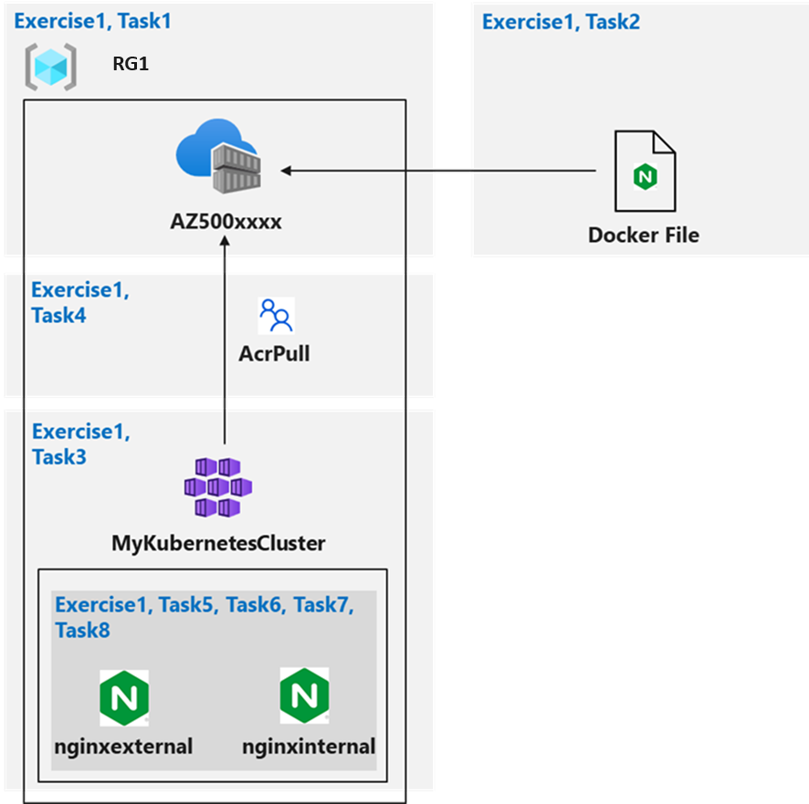

Instructions

Lab files:

* **nginxexternal.yaml**
* **nginxinternal.yaml**

Configuring and Securing ACR and AKS

Estimated timing: 120 minutes.

For all the resources in this lab, we are using the **West Europe** region. Verify with your instructor this is region to use for you class.

In this exercise, you will complete the following tasks:

* Task 1: Create an Azure Container Registry
* Task 2: Create a Dockerfile, build a container and push it to Azure Container Registry
* Task 3: Create an Azure Kubernetes Service cluster
* Task 4: Grant the AKS cluster permissions to access the ACR
* Task 5: Deploy an external service to AKS
* Task 6: Verify you can access an external AKS-hosted service
* Task 7: Deploy an internal service to AKS
* Task 8: Verify you can access an internal AKS-hosted service

Task 1: Create an Azure Container Registry

In this task, you will create a resource group for the lab an an Azure Container Registry.

1. Sign-in to the Azure portal [**https://portal.azure.com/**](https://portal.azure.com/).

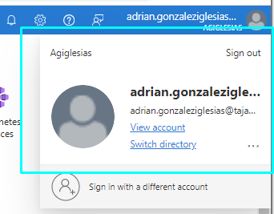

1. In the Azure portal, open the Cloud Shell by clicking the first icon in the top right of the Azure Portal. If prompted, click **Bash**.
2. Ensure **Bash** is selected in the drop-down menu in the upper-left corner of the Cloud Shell pane.

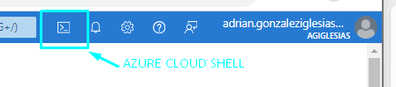

1. In the Bash session within the Cloud Shell pane, run a bash command to create a new resource group RG1 for this exam:

Creamos un grupo de recursos en la localidad eastus mediante az group create

1. In the Bash session within the Cloud Shell pane, run a new command to verify the resource group was created:

1. In the Bash session within the Cloud Shell pane, run a command to create a new Azure Container Registry (ACR) instance (The name of the ACR must be globally unique) with an SKU type Basic:

Creamos una instancia ACR indicando que va a tener un SKU básico

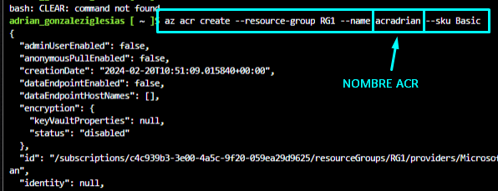

1. In the Bash session within the Cloud Shell pane, run a command to confirm that the new ACR was created:

**Note**: Record the name of the ACR. You will need it in the next task.

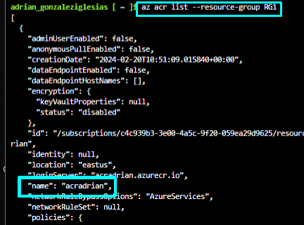

Task 2: Create a Dockerfile, build a container and push it to Azure Container Registry

In this task, you will create a Dockerfile, build an image from the Dockerfile, and deploy the image to the ACR.

1. In the Bash session within the Cloud Shell pane, run the following to create a Dockerfile to create a Nginx-based image:

echo FROM nginx > Dockerfile



1. In the Bash session within the Cloud Shell pane, run the following to build an image from the Dockerfile and push the image to the new ACR.

**Note**: The trailing period at the end of the command line is required. It designates the current directory as the location of Dockerfile.

ACRNAME=$(az acr list --resource-group RG1 --query '[].{Name:name}' --output tsv)

az acr build --resource-group RG1 --image sample/nginx:v1 --registry $ACRNAME --file Dockerfile –-sku Basic –-location eastus

**Note**: Wait for the command to successfully complete. This might take about 2 minutes.

1. Close the Cloud Shell pane.
2. In the Azure portal, navigate to the **RG1** resource group and, in the list of resources, click the entry representing the Azure Container Registry instance you provisioned in the previous task.
3. On the Container registry blade, in the **Services** section, click **Repositories**.
4. Verify that the list of repositories includes the new container image named **sample/nginx**.
5. Click the **sample/nginx** entry and verify presence of the **v1** tag that identifies the image version.
6. Click the **v1** entry to view the image manifest.

**Note**: The manifest includes the sha256 digest, manifest creation date, and platform entries.

Task 3: Create an Azure Kubernetes Service cluster

In this task, you will create an Azure Kubernetes service and review the deployed resources.

1. In the Azure portal, in the **Search resources, services, and docs** text box at the top of the Azure portal page, type **Kubernetes services** and press the **Enter** key.

1. On the **Kubernetes services** blade, click **+ Create** and, in the drop-down menu, click **+ Create a Kubernetes cluster.**

1. On the **Basics** tab of the **Create Kubernetes cluster** blade, select **Cluster preset configuration**, select **Dev/Test ($)**. Now specify the following settings (leave others with their default values):

| Setting | Value |
| --- | --- |
| Subscription | the name of the Azure subscription you are using in this lab |
| Resource group | **RG1** |
| Kubernetes cluster name | **MyKubernetesCluster** |
| Region | **West Europe** |
| Availability zones | **None** |
| Scale method | **Manual** |
| Node count | **1-2** |

1. Click **Next: Node Pools >** and, on the **Node Pools** tab of the **Create Kubernetes cluster** blade, specify the following settings (leave others with their default values):

| Setting | Value |
| --- | --- |
| Enable virtual nodes | cleared checkbox |

1. Click **Next: Access >**, on the **Access** tab of the **Create Kubernetes cluster** blade, accept the defaults, and click **Next: Networking >**.
2. On the **Networking** tab of the **Create Kubernetes cluster** blade, specify the following settings (leave others with their default values):

| Setting | Value |
| --- | --- |
| Network configuration | **Azure CNI** |
| DNS name prefix | **Leave the default value** |

**Note**: AKS can be configured as a private cluster. This assigns a private IP to the API server to ensure network traffic between your API server and your node pools remains on the private network only. For more information, visit [Create a private Azure Kubernetes Service cluster](https://docs.microsoft.com/en-us/azure/aks/private-clusters) page.

1. Click **Next: Integrations >** and, on the **Integrations** tab of the **Create Kubernetes cluster** blade, set **Container monitoring** to **Disabled**.

**Note**: In production scenarios, you would want to enable monitoring. Monitoring is disabled in this case since it is not covered in the lab.

1. Click **Review + Create** and then click **Create**.

**Note**: Wait for the deployment to complete. This might take about 10 minutes.

1. Once the deployment completes, in the Azure portal, in the **Search resources, services, and docs** text box at the top of the Azure portal page, type **Resource groups** and press the **Enter** key.

1. On the **Resource groups** blade, in the listing of resource groups, note a new resource group named **MC_RG1_MyKubernetesCluster_eastus** that holds components of the AKS Nodes. Review resources in this resource group.

Como podemos ver nos ha creado un rg referido al clúster

1. Navigate back to the **Resource groups** blade and click the **RG1** entry.

**Note**: In the list of resources, note the AKS Cluster and the corresponding virtual network.

1. In the Azure portal, open a Bash session in the Cloud Shell.

**Note**: Ensure **Bash** is selected in the drop-down menu in the upper-left corner of the Cloud Shell pane.

1. In the Bash session within the Cloud Shell pane, run the following to connect to the Kubernetes cluster:

az aks get-credentials --resource-group RG1 --name MyKubernetesCluster

con este comando crea un archivo .kube que contiene las credenciales

1. In the Bash session within the Cloud Shell pane, run a command to list nodes of the Kubernetes cluster:

**Note**: Verify that the **Status** of the cluster node is listed as **Ready**.

Listamos los nodos del cluster creado previamente

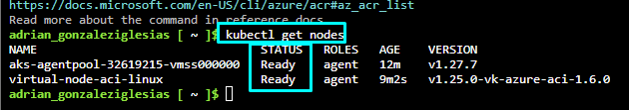

Task 4: Grant the AKS cluster permissions to access the ACR and manage its virtual network

In this task, you will grant the AKS cluster permission to access the ACR and manage its virtual network.

1. In the Bash session within the Cloud Shell pane, run the following to configure the AKS cluster to use the Azure Container Registry instance you created earlier in this lab.

ACRNAME=$(az acr list --resource-group RG1 --query '[].{Name:name}' --output tsv)

az aks update -n MyKubernetesCluster -g RG1 --attach-acr $ACRNAME

**Note**: This command grants the ‘acrpull’ role assignment to the ACR.

**Note**: It may take a few minutes for this command to complete.

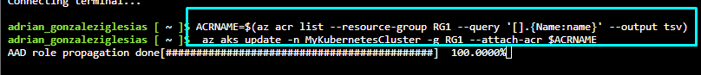

1. In the Bash session within the Cloud Shell pane, run the following to grant the AKS cluster the Contributor role to its virtual network.

RG_AKS=RG1

AKS_VNET_NAME=RG1-vnet

AKS_CLUSTER_NAME=MyKubernetesCluster

AKS_VNET_ID=$(az network vnet show --name $AKS_VNET_NAME --resource-group $RG_AKS --query id -o tsv)

AKS_MANAGED_ID=$(az aks show --name $AKS_CLUSTER_NAME --resource-group $RG_AKS --query identity.principalId -o tsv)

az role assignment create --assignee $AKS_MANAGED_ID --role "Contributor" --scope $AKS_VNET_ID

Asignamos el rol de contributor al cluster en su red virtual

Task 5: Deploy an external service to AKS

In this task, you will download the Manifest files, edit the YAML file, and apply your changes to the cluster.

1. In the Bash session within the Cloud Shell pane, click the **Upload/Download files** icon, in the drop-down menu, click **Upload**, in the **Open** dialog box, navigate to the location where you downloaded the lab files, select **\Allfiles\Labs\09\nginxexternal.yaml** click **Open**. Next, select **\Allfiles\Labs\09\nginxinternal.yaml**, and click **Open**.

Subimos los .yaml de uno en uno, ya que si subimos los dos a la vez solo se subirá el primero que se ha marcado

1. In the Bash session within the Cloud Shell pane, run the following to identify the name of the Azure Container Registry instance:

echo $ACRNAME

**Note**: Record the Azure Container Registry instance name. You will need it later in this task.

1. In the Bash session within the Cloud Shell pane, run the following to open the nginxexternal.yaml file, so you can edit its content.

code ./nginxexternal.yaml

**Note**: This is the *external* yaml file.

1. In the editor pane, scroll down to **line 24** and replace the **<ACRUniquename>** placeholder with the ACR name.

1. In the editor pane, in the upper right corner, click the **ellipses** icon, click **Save** and then click **Close editor**.
2. In the Bash session within the Cloud Shell pane, run a command to apply the change to the cluster:

1. In the Bash session within the Cloud Shell pane, review the output of the command you run in the previous task to verify that the deployment and the corresponding service have been created.

deployment.apps/nginxexternal created

service/nginxexternal created

Como vemos en la foto anterior nos muestra que han sido creados correctamente

Task 6: Verify you can access an external AKS-hosted service

In this task, verify the container can be accessed externally using the public IP address.

1. In the Bash session within the Cloud Shell pane, run a command to retrieve information about the nginxexternal service including name, type, IP addresses, and ports.

1. In the Bash session within the Cloud Shell pane, review the output and record the value in the External-IP column. You will need it in the next step.

20.160.254.76

1. Open a new browser tab and browse to the IP address you identified in the previous step.
2. Ensure the **Welcome to nginx!** page displays.

Task 7: Deploy an internal service to AKS

In this task, you will deploy the internal facing service on the AKS.

1. In the Bash session within the Cloud Shell pane, run the following to open the nginxintenal.yaml file, so you can edit its content.

code ./nginxinternal.yaml

**Note**: This is the *internal* yaml file.

1. In the editor pane, scroll down to the line containing the reference to the container image and replace the **<ACRUniquename>** placeholder with the ACR name.

1. In the editor pane, in the upper right corner, click the **ellipses** icon, click **Save** and then click **Close editor**.
2. In the Bash session within the Cloud Shell pane, run a command to apply the change to the cluster:

1. In the Bash session within the Cloud Shell pane, review the output to verify your deployment and the service have been created:

deployment.apps/nginxinternal created

service/nginxinternal created

Como vemos en la foto anterior nos muestra que han sido creados correctamente

1. In the Bash session within the Cloud Shell pane, run the following to retrieve information about the nginxinternal service including name, type, IP addresses, and ports.

kubectl get service nginxinternal

1. In the Bash session within the Cloud Shell pane, review the output. The External-IP is, in this case, a private IP address. If it is in a **Pending** state then run the previous command again.

**Note**: Record this IP address. You will need it in the next task.

**Note**: To access the internal service endpoint, you will connect interactively to one of the pods running in the cluster.

**Note**: Alternatively, you could use the CLUSTER-IP address.

Task 8: Verify you can access an internal AKS-hosted service

In this task, you will use one of the pods running on the AKS cluster to access the internal service.

1. In the Bash session within the Cloud Shell pane, run a command to list the pods in the default namespace on the AKS cluster:

1. In the listing of the pods, copy the first entry in the **NAME** column.

**Note**: This is the pod you will use in the subsequent steps.

nginxexternal-59b98b8cf7-tbrfl

nginxinternal-59b56d855f-8sdnw

1. In the Bash session within the Cloud Shell pane, run the following to connect interactively to the first pod (replace the <pod_name> placeholder with the name you copied in the previous step):

kubectl exec -it <pod_name> -- /bin/bash

Como vemos nos da un error de que no encuentra el conteneder y entre paréntesis nos pone (**nginx**)…esto se debe en principio a que hay un problema con el contenedor pero viendo y revisando que esta todo bien configurado, se debe a que no hemos conseguido instalar el nginx en el primer paso del laboratorio.

1. In the Bash session within the Cloud Shell pane, run a command to verify that the nginx web site is available via the private IP address of the service (replace the <internal_IP> placeholder with the IP address you recorded in the previous task):

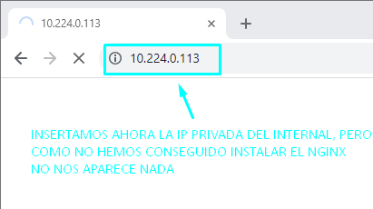

1. Close the Cloud Shell pane.

Result: You have configured and secured ACR and AKS.

**Task 9: Clean up resources.**

Remember to remove any newly created Azure resources that you no longer use. Removing unused resources ensures you will not incur unexpected costs.

1. In the Azure portal, open the Cloud Shell by clicking the first icon in the top right of the Azure Portal.
2. In the upper-left drop-down menu of the Cloud Shell pane, select **PowerShell** and, when prompted, click **Confirm**.
3. In the PowerShell session within the Cloud Shell pane, run a command to remove the resource group **RG1** you created in this exam:
4. Close the **Cloud Shell** pane.

